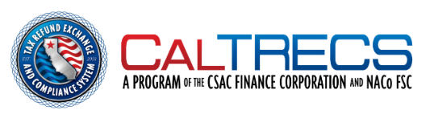

Letter of Agreement
This Letter of Agreement is between the TRECS Participating Agency ___________________ (hereafter referred to as the “Agency”) and the TRECS Clearinghouse (hereafter referred to as the “Clearinghouse”).
The Agency agrees to utilize the TRECS Clearinghouse Letter Service for one tax-cycle year from ________________ (date) to _______________ (date). The Agency understands that the Clearinghouse will mail notices to Debtor Offset Candidates as specified under California Government Code 12419.8 on the Agency’s behalf.
The Clearinghouse agrees to abide by all California Codes regarding the notification letter set forth under 12419.8. The Clearinghouse agrees to make available a copy of the letters mailed to the Agency through their secure online portal.
The Agency reaffirms that they will abide by all requirements as set forth in the Memorandum of Understanding between the Agency and the California State Association of Counties Finance Corporation to participate in the TRECS Clearinghouse. This includes maintaining up-to-date records with the Clearinghouse and maintaining responsibility for all debtor contestations that may arise from the Clearinghouse Letter Service.
The Agency agrees to pay the Clearinghouse $2.00 per letter. The Clearinghouse agrees to invoice the Agency monthly for the previous month’s letters. The Agency agrees to pay the invoice within 30 days of receiving the invoice.

______________________________________ Signature of Authorized Agency Representative
______________________________________ Printed Signature
______________________________________ Name of Agency
______________________________________ Date

______________________________________ Signature of Authorized Clearinghouse Representative
______________________________________ Printed Signature
______________________________________ Date

