File Fail Cheat Sheet

During the upload process, once you hit the upload button and the message “File Successfully Uploaded” comes up in a green bar at the top of the screen, you will need to verify that it has met the formatting requirements.
Verify that the file has processed successfully by checking your email a couple minutes after clicking the Upload button.

- If the file has processed successfully, you will receive an email titled “File Successfully Processed”
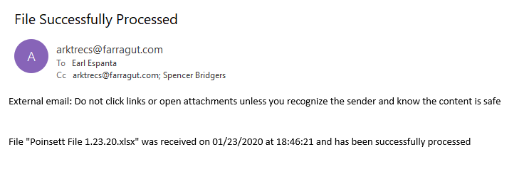
- If the file does not process successfully, you will receive an email titled “File Failed”. This file may contain various messages pertaining to why exactly the file failed. *NOTE: only 15 lines of errors are shown at one time. If you have more than 15 errors and you correct all errors and reupload, you will receive another email with other errors needed to be fixed.*
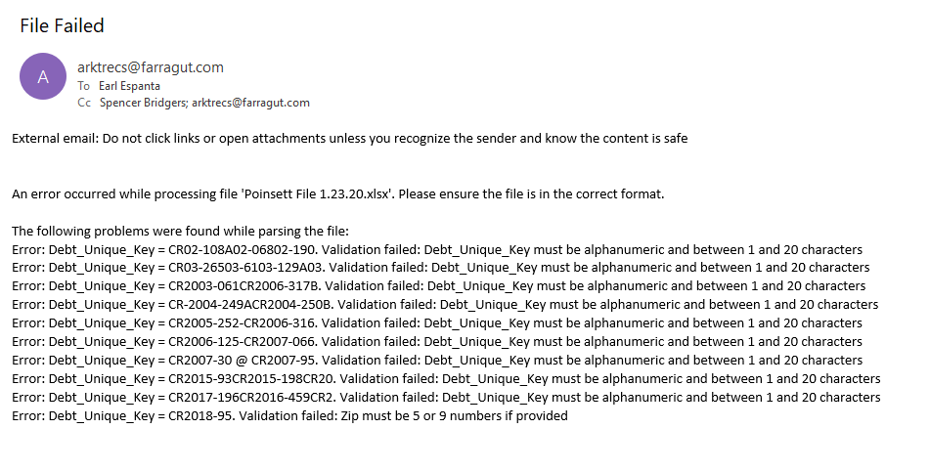
Referencing this line in the File Failed email:
- Debt_Unique_Key = CR02-108A02-06802-190.
  - This section is giving you reference to which specific Debt Unique Key is in error for the file that is being submitted. Using the search function in excel and the specific debt unique key referenced, you can easily find the row that is in error.
- Debt_Unique_Key must be alphanumeric and between 1 and 20 characters
  - This section references the specific error causing the row to be flagged. In this case, the debt unique key may be too long or contain symbols not allowed.
A list of possible errors is shown below:
Error Message
'First Name must be between 2 and 50 characters'
'Primary_LastName must be at least 2 characters'
'FullPrimaryOwnerName must be at least 5 characters'
AddressLine1 must be between 1 and 100 characters'
'AddressLine2 must be a maximum of 100 characters'
City must be between 1 and 50 characters'
'State must be 2 characters'
Zip must be 5 or 9 numbers'
'DebtAmount must be numeric and no more than 11 digits'
'Debt_Exp_Date must be a valid date'
'Debt_Compliance_Date must be a valid date'
'Debt_Unique_Key must be alphanumeric and between 1 and 20 characters'
'Secondary_FirstName must be between 2 and 50 characters'
'Secondary_LastName must be between 2 and 50 characters'
'Secondary_MiddleName must be a maximum of 50 characters'
'Record Date must be of the form YYYYMMDD'
Debt Account Number must be no more than 25 characters'
'Source Code must be no more than 20 characters'
'Email must be no more than 50 characters'
Phone number must be no more than 12 characters'
'DOB must be a valid date of the form YYYYMMDD'
'SSN must be no more than 9 characters'
'This debt unique key is used by multiple records in the uploaded file.'
'Error: Blank line(s) detected.'
'. Validation failed: The record with this debt unique key is missing from the uploaded file.'

Common Mistakes to Lookout For
- The Zip Code started with a “0” and excel formatted it to be four numbers rather than five
  - Ex. “01234” reformatted to “1234”
- Debt Unique Key is too long
- Debt Unique Key contains symbols not allowed
- Birthday is formatted incorrectly
- SSN contains too many numbers
- Debt Unique Key is the same for two records
- Not all required fields are filled out

